Fibre to Fabric
In this lesson, let’s explore the following objectives:
1. Identify sources of natural fibres
2. Identify properties of natural fibres
3. Identify synthetic fibres
4. Identify common properties of synthetic fibres
Introduction
What do you wear today? We all wear fashionable clothes today. But were they available during the older days? Let’s go back to the Stone Age. Do the people of the Stone Age wear clothes as we wear today? No. They were using the animal’s skin to protect from heat and cold. Some prehistoric people use even leaves to cover their body. There was no proper information about when people started wearing clothes.
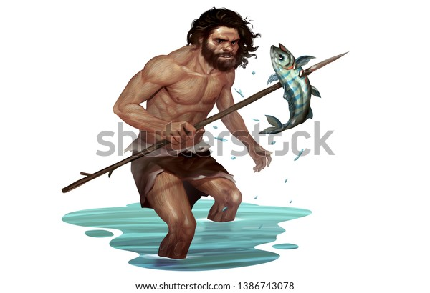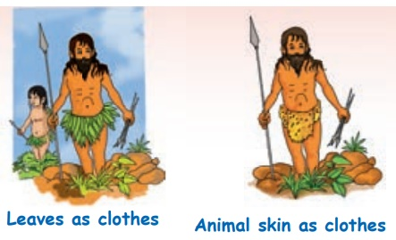
Then how do they get the idea of wearing clothes? Well, they used to sew animal skin when they tear. They used the same technique to sew the cloth. Cloth or clothing is a different type of materials we wore on the body to protect us from heat, cold, rain and any weather conditions.
But how clothes are made? Do we obtain it directly? As the time passed, people started to make yarns from plant fibres and also from animal fibres. Later, they sew the fibres to make a beautiful cloth. Neanderthals was the first people to sew clothes as they sew animal skin.
Sources of Natural Fibres
A material which is available in the form of thin and continuous strand is known as fibre. They are extremely long threads that can be converted into yarns which in turn are converted into fabrics.
Did you know?
The word ‘fiber’ comes from the Latin phrase which means ‘it looks like threads’.
Fibres can be classified into two types:
- Natural Fibres and
- Synthetic Fibres
Interested to watch a video on types of Fibres: https://www.youtube.com/watch?v=PQ_8lZS56qQ
Natural Fibres: As the name implies; the fibres that are obtained from plants and animals are called natural fibres.
Examples of natural plant fibres:
- Cotton from cotton plants
- Jute from jute plants
Examples of natural animal fibres:
- Silk from cocoon of silkworm
- Wool from the fleece of animals like goat and sheep and
- Wool from the hair of rabbits, yak and camels.
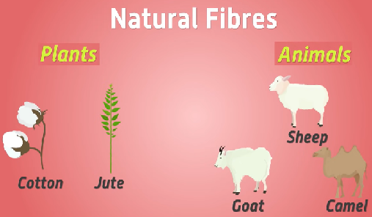

Sources of Natural Fibres
Most natural fibres are known to be good absorbers of sweat and other liquids. Now, that you all are aware of natural fibres, let’s study some of its properties.
Do you know?
Cotton is the commonly used fabric in the textile world. This fabric dates back to the 3000 B.C. in Egypt
Properties of natural fibres
- Cotton is a natural fibre obtained from plants, it is light in weight, feels soft and smooth.
- Jute is another natural fibre obtained from plants and it is rough and a strong fibre.
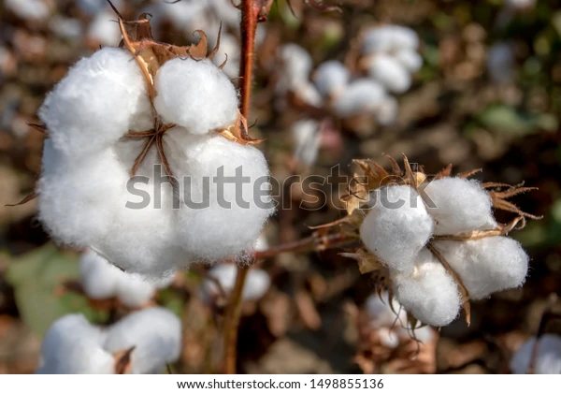
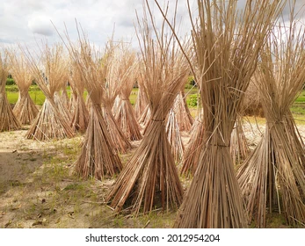

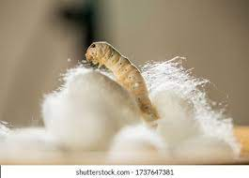
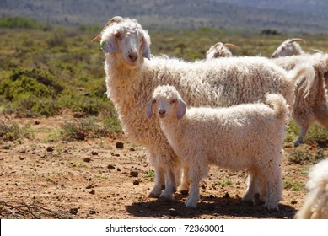
- Cotton from cotton plant b. Jute from jute plant

- Silk from silk worm d. Angora Wool from goats
Silk is an example of natural animal fibre, it has soft and shiny nature. You must have seen silk sarees from the regions of TamilNadu. Their texture is so soft and it is shiny. Original silk sarees are woven from the silk obtained from silk worm.
Wool is a good example for natural animal fibre, it is fluffy and smooth in nature. Since it is fluffy, it will trap the air inside and make us feel warm. This is the reason why we use woolen clothes in winter.
But, if we continuously rely on the natural sources of fibre, either from plants or animals, would we able to wear the fashionable clothes of today? Why?
Even though natural sources of fibres are available, to meet the needs of clothes of people around the world, the natural sources are not sufficient. Moreover, do you know that we have to kill the silkworms to get silk? So, we have to think of an alternative for making our clothes. This thought give rise to synthetic fibres. Let’s see what are the sources of synthetic fibres and how they are made?
Interested to know more about Cotton?
Have a look at the 10 interesting facts about Cotton: https://www.youtube.com/watch?v=11H70RH8N-Q
Synthetic Fibres: Natural fibres were the only type of fibres that were available for making fabrics for thousands of years. Later, fibres were made from chemical substances prepared from raw material petroleum called petrochemicals.
These types of fibres are called synthetic fibres or man-made fibres or artificial fibres.
Examples of synthetic fibres are Polyester, Rayon, Nylon and Acrylic.
Identifying Synthetic Fibres:
Polyesters:
- Polyesters are widely used in clothing fabrics.
Examples include polyester shirts, jackets, pants, polyester hats, etc.
- Polyester is used in making furnitures.
- They are used in home furnishing materials such as bed sheets, curtains, blankets, and pillowcases
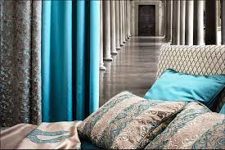
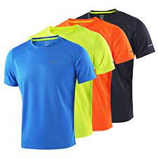

Polyester Clothing Polyester Home furnishings
Rayon:
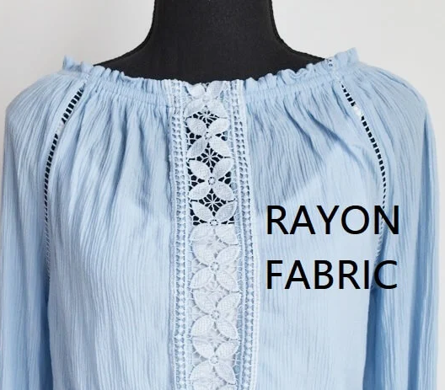
Rayon is synthetic fibre with similar characteristics with that of silk and it is cheaper than silk. It is extracted from the pulp of wood. Rayon is widely used in clothing industry.
When infused with cotton or wool, it is used for the preparation of bed sheets and carpets.

Nylon:
It is often used to make satins, chiffons, fishing nets, ropes, parachutes, etc. Nylon is strong, machine washable, wrinkle-resistant and elastic, but it does not absorb well.

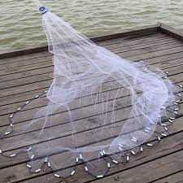
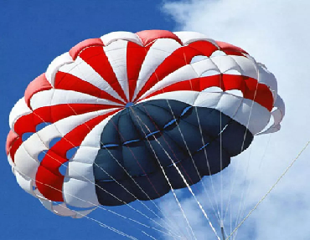

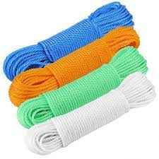

Nylon fishing net Nylon ropes Nylon Parachute

Acrylic:
It is strong, machine washable, wrinkle resistant and dyes well, but it pills and cannot absorb very well. It is often used in fake fur, knits, and fleece and as an imitation of wool. It blends with wool, cotton and rayon as well.

Do you know?
Nylon is the first synthetic fibre developed by Wallace Carothers, an American researcher at the chemical firm DuPont in the 1930’s.

Properties of Synthetic fibres:

- They are soft and lightweight,
- Durable and do not wrinkle easily.
- Dust and impurities are less in synthetic fibres.
- They are strong and can sustain the heavy load.
- They are elastic and can be easily stretched out.
- Synthetic fibres are water, stain, heat and chemical resistant.
- They are not attacked by moths.
- They are cheaper as compared to natural fibres.

So we know, the different types of fibres. Let’s see how woolen clothes are obtained from the natural fibres of animals. What is the process involved during the making of wool?
Natural Fibres from Animals
Wool: Wool is a protein composed of amino acids, very much like our skin and hair. In different world regions, particular wool fibres traditionally enjoyed the highest popularity.

In Europe: Sheep, goat, mohair and angora.

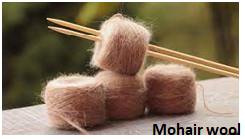

In Middle East: wool from Camel (Kazakh).

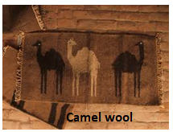

In the foothills of Himalayas: Cashmere

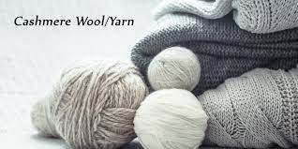

The production technologies have advanced with times and thus these days, we have access to any wool fabric type. That is why it is important to know some important features of wool.
1. Features of wool
a. Warm | Wool fabrics are perfect for winter apparel, because wool fibres’ do not conduct heat and allow the body to keep its temperature.
- Strong | Wool fabrics are strong, durable and resistant to tear.
- Flexible | Wool fibres’ are naturally elastic and capable of stretching.
- Absorbs moisture | Wool fibres’ are water-repellent and absorb moisture.
- Dyes easily | Wool fabrics can be dyed in any color and are colorfast.
- Biodegradable | When a wool product is buried in soil, it is naturally biodegradable and provides nutrients to the soil.

2. Process of making wool
We know that wool comes from sheep, but how it transforms from a sheep’s fur to material to be worn is a journey. Wool goes through a multi-step process to clean it, regularize it and transforms it into soft yarn. Although machinery can make the process much faster today, in most ways the process is the same as how people have been preparing wool for centuries. Let’s look into the different steps.

- Shearing the Sheep: Sheep farmers shear their sheep using an electric tool similar to a razor that removes the sheep’s entire fleece in one piece.
- Cleaning the wool: A simple step of washing the wool which removes dirt, other contaminants and natural oils from the wool.
- Carding the wool: Carding is a process that pulls them through fine metal teeth.
- Spinning the wool into yarn: Spinning turns the wool pieces into a material that’s usable. Spinning uses a wheel to spin 2-5 strands of wool together.

Weaving and Knitting: The process of arranging two sets of yarns together to make a fabric is called weaving. In knitting, a single yarn is used to make a piece of fabric. Some wool yarn is sold directly to consumers, who use it to craft hand-made scarves, sweaters and other clothing.

Dyeing: Wool quickly absorbs water, which makes it very easy to dye. It can be dyed at almost any stage of the process, depending on what the final product will be.

Silk
Silk is an animal fibre produced by certain insects and arachnids as building material for cocoons and webs, some of which can be used to make fine fabrics. Silk is the only continuous natural fibre and like wool, it’s a protein-based fibre.
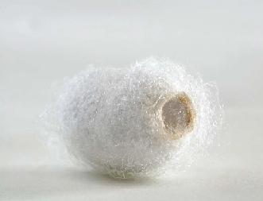

- Features of silk:
- Elasticity | Silk is flexible and has some elasticity to it which allows it to pull itself back into shape after stretching to some extent.
- Absorbency | Silk is fairly absorbent. Water weakens the fibres.
- Lightweight and breathable | Silk is a lightweight, breathable fabric, which means it reduces the risk of overheating when you’re going about your day.
- Thermal regulation | Silk’s good at maintaining your body temperature which means it can help you feel cool in hot weather and warm in the cold.
- Drying speed | Silk is fast drying which makes it highly practical when managing your laundry or just going about your day-to-day business.

2. Process of making silk:

Step 1: Sericulture
The term Sericulture is used to describe the process of gathering the silkworms and harvesting the cocoon to collect the materials. Silkworms are really not worms; they are the larvae of “bombyx mori” moths. Silkworms are actually domesticated insects, incapable of flight, mate quickly after emerging from their chrysalis and die a day or so after laying eggs.
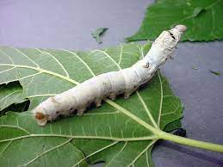

Step 2: Thread extraction
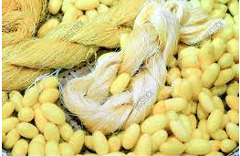
The next step is the thread extraction. After the silkworms have spun their cocoon, they will eventually enclose themselves inside it and then it’s time to extract the silk threads.

Step 3: Dyeing
Silk yarns are washed and degummed by immersing the skins in large tubs of hot water. After this process, there is also a bleaching and drying process. Dyes are prepared in a dye bath. Once the dye is ready, the bundles of clean threads are then immersed in the dye bath for several times over many days to achieve the proper color tone and quality.
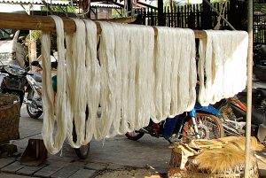

Step 4: Spinning

The traditional spinning wheel has always and will always be an integral part of the silk production process. Using spinning wheels, dyed silk skins are then unwound by hands onto wooden or plastic bobbins to be prepared for warp or weft in the weaving process.

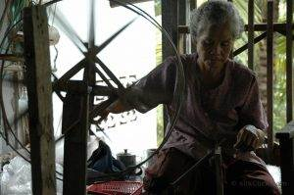

Step 5: Weaving

Weaving is the process in which the final piece of silk comes together. There are many different ways in which silk can be woven such as satin weave, plain weave and open weave are most common and the finish of the silk will depend on the type of the weave. Generally, weaving involves interlacing two sets of threads so that they lock around each other and create a strong, uniform piece of fabric.
